Module 5
Transactions, Concurrency and Recovery, Recent Topics
Transaction Processing Concepts - overview of concurrency control, Transaction Model, Significance of concurrency Control & Recovery, Transaction States, System Log, Desirable Properties of transactions.
Serial schedules, Concurrent and Serializable Schedules, Conflict equivalence and conflict serializability, Recoverable and cascade-less schedules, Locking, Two-phase locking and its variations. Log-based recovery, Deferred database modification, check-pointing.
Introduction to NoSQL Databases, Main characteristics of Key-value DB (examples from: Redis), Document DB (examples from: MongoDB)
Main characteristics of Column - Family DB (examples from: Cassandra) and Graph DB (examples from : ArangoDB)
Transaction Processing Concepts
Transactions
- A Database Transaction is a logical unit of processing in a DBMS which entails one or more database access operation.
- The operations performed in a transaction include one or more of database operations like insert, delete, update or retrieve data.
Single User and Multi user Database Systems
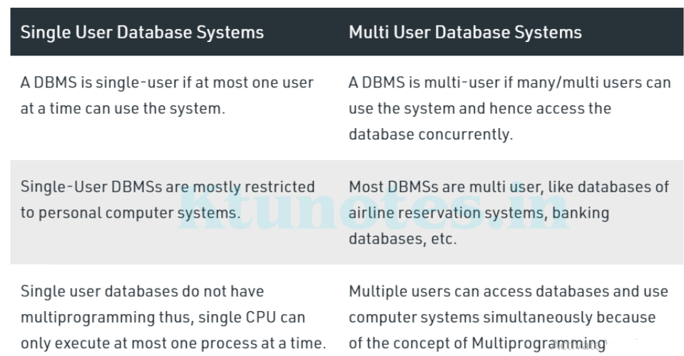
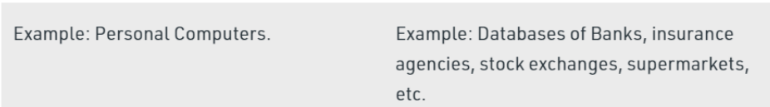
Overview of Concurrency Control and Recovery
Concurrency may be achieved by Interleaved Processing, where processes are executed in an interleaved fashion with a single CPU or by Parallel Processing, where processes are concurrently executed in multiple CPUs.
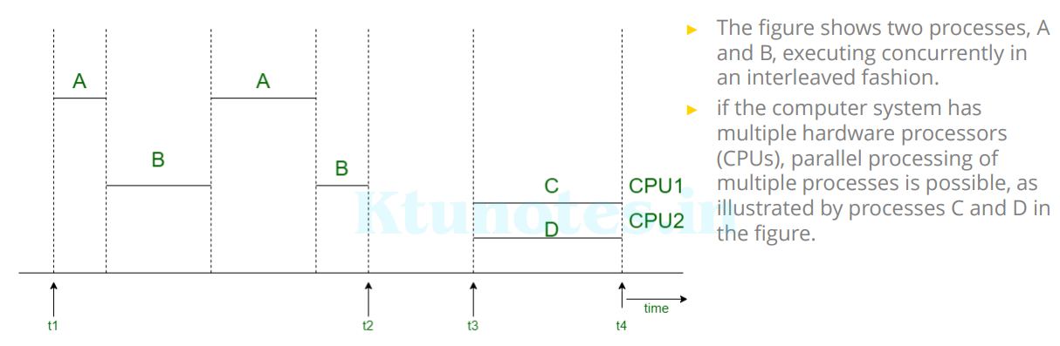

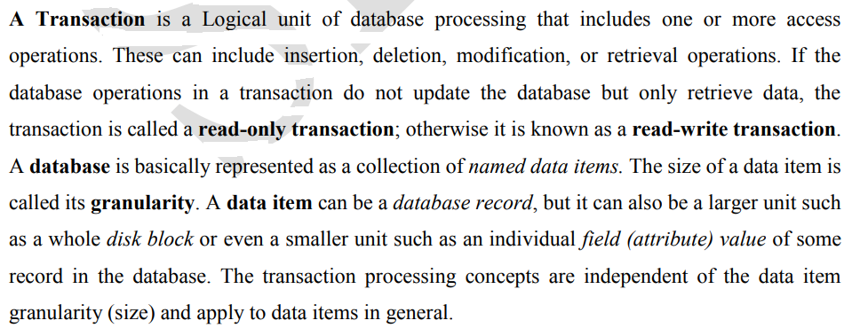
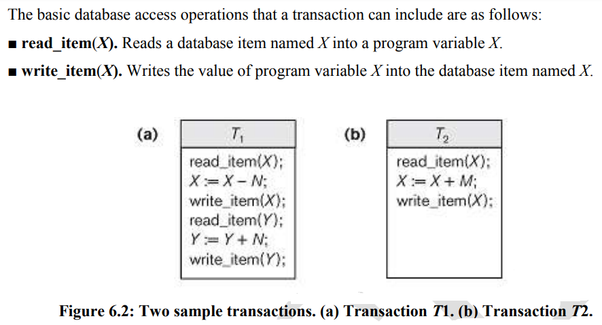
Transaction Operations
The low level operations performed in a transaction are –
- begin_transaction: This marks the beginning of transaction execution.
- read or write: These specify read or write operations on the database items that are executed as part of a transaction.
- end_transaction: This specifies that read and write transaction operations have ended and marks the end limit of transaction execution.
At this point it may be necessary to check whether the changes introduced by the transaction can be permanently applied to the database or whether the transaction has to be aborted because it violates concurrency control or for some other reason.
- commit_transaction: This signals a successful end of the transaction so that any changes (updates) executed by the transaction can be safely committed to the database and will not be undone.
- rollback (or abort): This signals that the transaction has ended unsuccessfully, so that any changes or effects that the transaction may have applied to the database must be undone.
Why Concurrency Control is Needed:
- When multiple transactions execute concurrently in an uncontrolled or unrestricted manner, then it might lead to several problems.
- These problems are commonly referred to as concurrency problems in database environment.
- The five concurrency problems that can occur in database are:
► Temporary Update Problem
► Incorrect Summary Problem
► Lost Update Problem
► Unrepeatable Read Problem

Temporary Update Problem
- Temporary update or dirty read problem occurs when one transaction updates an item and fails.
- But the updated item is used by another transaction before the item is changed or reverted back to its last value.
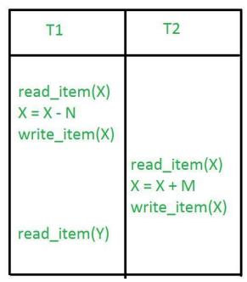
► In this example, if transaction 1 fails for some reason then X will revert back to its previous value. ► But transaction 2 has already read the incorrect value of X.

Incorrect Summary Problem
- Consider a situation, where one transaction is applying the aggregate function on some records while another transaction is updating these records.
- The aggregate function may calculate some values before the values have been updated and others after they are updated.
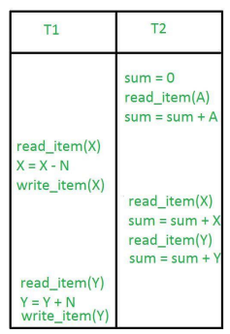
► In this example, transaction 2 is calculating the sum of some records while transaction 1 is updating them.
► Therefore the aggregate function may calculate some values before they have been updated and others after they have been updated.

Unrepeatable Read Problem
- The unrepeatable problem occurs when two or more read operations of the same transaction read different values of the same variable.
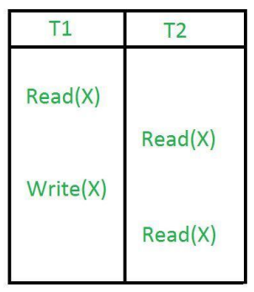 ► In this example, once transaction 2 reads the variable X, a write operation in transaction 1 changes the value of the variable X. ► Thus, when another read operation is performed by transaction 2, it reads the new value of X which was updated by transaction 1.

Lost Update Problem
- In the lost update problem, update done to a data item by a transaction is lost as it is overwritten by the update done by another transaction.
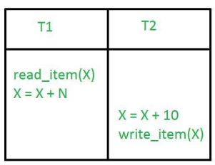
► In this example, transaction 1 changes the value of X but it gets overwritten by the update done by transaction 2 on X. ► Therefore, the update done by transaction 1 is lost.
Why Recovery is Needed: (What Causes a Transaction to Fail?)
Whenever a transaction is submitted to a DBMS for execution
- The system is responsible for making sure that either all the operations in the transaction are completed successfully and their effect is recorded permanently in the database or that the transaction does not have any effect on the database or any other transactions.
Types of Failures
- A computer failure (system crash) -A hardware, software, or network error occurs in the computer system during transaction execution.
- A transaction or system error. Some operation in the transaction may cause it to fail,
► Integer overflow or division by zero.
► Erroneous parameter values
► Logical programming error.
► User may interrupt the transaction during its execution
- Local errors or exception conditions detected by the transaction - During transaction execution, certain conditions may occur that necessitate cancellation of the transaction.
► Eg: Insufficient account balance in a banking database, may cause a transaction,
such as a fund withdrawal, to be canceled.
- Disk failure - Some disk blocks may lose their data because of a read or write malfunction or because of a disk read/write head crash. This may happen during a read or a write operation of the transaction.
- Physical problems and catastrophes. - This refers to an endless list of problems that includes power or air-conditioning failure, fire, theft, sabotage, overwriting disks or tapes by mistake, and mounting of a wrong tape by the operator.
- Concurrency control enforcement -The concurrency control method may decide to abort the transaction, to be restarted later, because it violates serializability or because several transactions are in a state of deadlock.
Transaction States:
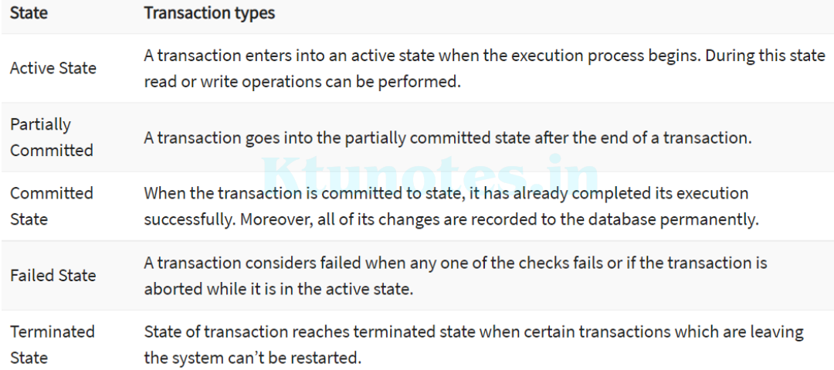
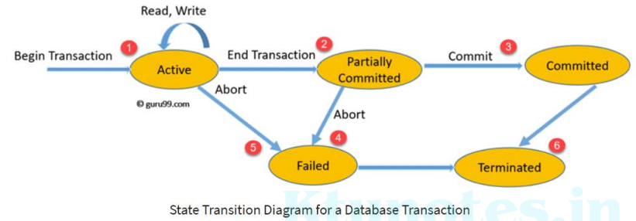
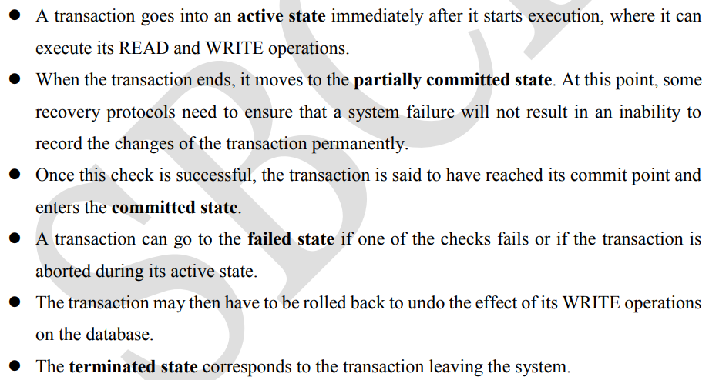
The System Log
- To be able to recover from failures that affect transactions, the system maintains a log
- to keep track of all transaction operations that affect the values of database items,
- as well as other transaction information that may be needed to permit recovery from failures.
- In a stable storage, logs for each transaction are maintained.
- Any operation which is performed on the database is recorded is on the log.
- Prior to performing any modification to database, an update log record is created to reflect that modification.
- The log is kept on disk, so it is not affected by any type of failure except for disk or catastrophic failure.
- T in the following discussion refers to a unique transaction-id that is generated automatically by the system and is used to identify each transaction:
Types of Log Record:
1. [start_transaction, T] - Indicates that transaction T has started execution.
2. [write_item, T, X, old_value, new_value] - Indicates that transaction T has changed
the value of database item X from old_value to new_value.
3. [read_item, T, X] - Indicates that transaction T has read the value of database item X.
4. [commit, T] - Indicates that transaction T has completed successfully, and affirms that
its effect can be committed (recorded permanently) to the database.
5. [abort, T] - Indicates that transaction T has been aborted.

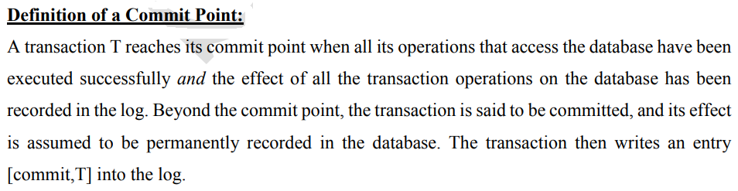
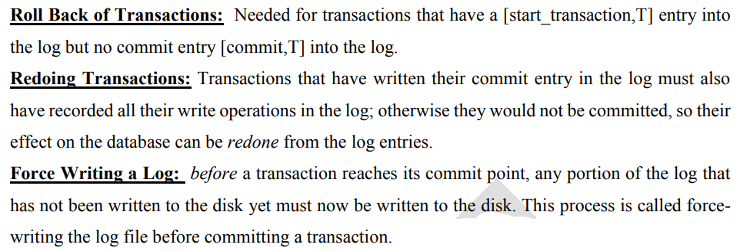
ACID Properties (Desirable Properties of Transactions)
ACID Properties are used for maintaining the integrity of database during transaction processing.
► ACID in DBMS stands for Atomicity, Consistency, Isolation, and Durability.
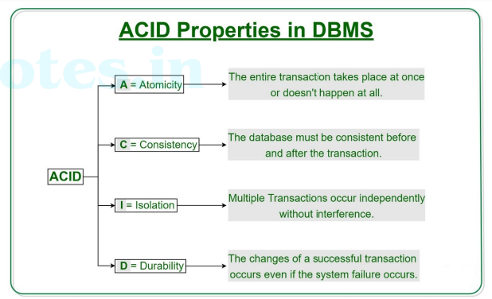
Atomicity
- By this, we mean that either the entire transaction takes place at once or doesn’t happen at all.
- There is no midway i.e. transactions do not occur partially.
- Each transaction is considered as one unit and either runs to completion or is not executed at all.
- It involves the following two operations.
► Abort: If a transaction aborts, changes made to database are not visible.
► Commit: If a transaction commits, changes made are visible.
- Atomicity is also known as the ‘All or nothing rule’.
- Consider the following transaction T consisting of T1 and T2: Transfer of 100 from account X to account Y.
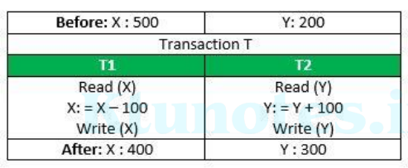
- If the transaction fails after completion of T1 but before completion of T2.( say, after write(X) but before write(Y)), then amount has been deducted from X but not added to Y.
- This results in an inconsistent database state. Therefore, the transaction must be executed in entirety in order to ensure correctness of database state.
Consistency
- This means that integrity constraints must be maintained so that the database is consistent before and after the transaction.
- It refers to the correctness of a database.
- Referring to the example above, the total amount before and after the transaction must be maintained.
- Total before T occurs = 500 + 200 = 700.
- Total after T occurs = 400 + 300 = 700.
- Therefore, database is consistent. Inconsistency occurs in case T1 completes but T2 fails. As a result T is incomplete.
Isolation
- In a database system where more than one transaction are being executed simultaneously and in parallel, the property of isolation states that all the transactions will be carried out and executed as if it is the only transaction in the system.
- No transaction will affect the existence of any other transaction.
- Let X= 500, Y = 500. Consider two transactions T and T”.
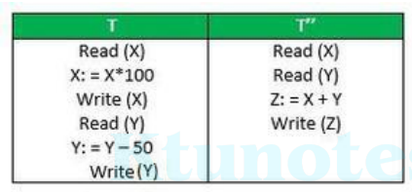
- Suppose T has been executed till Read (Y) and then T’’ starts. As a result , interleaving of operations takes place due to which T’’ reads correct value of X but incorrect value of Y and sum computed by
- T’’: (X+Y = 50, 000+500=50, 500) is thus not consistent with the sum at end of transaction:
- T: (X+Y = 50, 000 + 450 = 50, 450).
- This results in database inconsistency, due to a loss of 50 units. Hence, transactions must take place in isolation and changes should be visible only after they have been made to the main memory.
Durability
- The database should be durable enough to hold all its latest updates even if the system fails or restarts.
- If a transaction updates a chunk of data in a database and commits, then the database will hold the modified data.
- If a transaction commits but the system fails before the data could be written on to the disk, then that data will be updated once the system springs back into action.

Introduction to NoSQL
NoSQL is a type of database management system (DBMS) that is designed to handle and store large volumes of unstructured and semi-structured data. Unlike traditional relational databases that use tables with pre-defined schemas to store data, NoSQL databases use flexible data models that can adapt to changes in data structures and are capable of scaling horizontally to handle growing amounts of data.
The term NoSQL originally referred to “non-SQL” or “non-relational” databases, but the term has since evolved to mean “not only SQL,” as NoSQL databases have expanded to include a wide range of different database architectures and data models.
NoSQL databases are generally classified into four main categories:
1)Document databases: These databases store data as semi-structured documents, such as JSON or XML, and can be queried using document-oriented query languages.
2)Key-value stores: These databases store data as key-value pairs, and are optimized for simple and fast read/write operations.
3)Column-family stores: These databases store data as column families, which are sets of columns that are treated as a single entity. They are optimized for fast and efficient querying of large amounts of data.
4)Graph databases: These databases store data as nodes and edges, and are designed to handle complex relationships between data.
NoSQL databases are often used in applications where there is a high volume of data that needs to be processed and analyzed in real-time, such as social media analytics, e-commerce, and gaming. They can also be used for other applications, such as content management systems, document management, and customer relationship management.
Key Features of NoSQL:
- Dynamic schema: NoSQL databases do not have a fixed schema and can accommodate changing data structures without the need for migrations or schema alterations.
- Horizontal scalability: NoSQL databases are designed to scale out by adding more nodes to a database cluster, making them well-suited for handling large amounts of data and high levels of traffic.
- Document-based: Some NoSQL databases, such as MongoDB, use a document-based data model, where data is stored in a schema-less semi-structured format, such as JSON or BSON.
- Key-value-based: Other NoSQL databases, such as Redis, use a key-value data model, where data is stored as a collection of key-value pairs.
- Column-based: Some NoSQL databases, such as Cassandra, use a column-based data model, where data is organized into columns instead of rows.
- Distributed and high availability: NoSQL databases are often designed to be highly available and to automatically handle node failures and data replication across multiple nodes in a database cluster.
- Flexibility: NoSQL databases allow developers to store and retrieve data in a flexible and dynamic manner, with support for multiple data types and changing data structures.
- Performance: NoSQL databases are optimized for high performance and can handle a high volume of reads and writes, making them suitable for big data and real-time applications.
When should NoSQL be used:
- When a huge amount of data needs to be stored and retrieved.
- The relationship between the data you store is not that important
- The data changes over time and is not structured.
- Support of Constraints and Joins is not required at the database level
- The data is growing continuously and you need to scale the database regularly to handle the data.
Characteristics of Key-Value DB(Ex: Redis)
Definition and Characteristics:
- A key-value database is a type of NoSQL database that stores data as a collection of key-value pairs, where each key is unique.
- It's designed for simplicity, high performance, and horizontal scalability.
- Key-value databases are schema-less, offering flexibility in storing unstructured or semi-structured data.
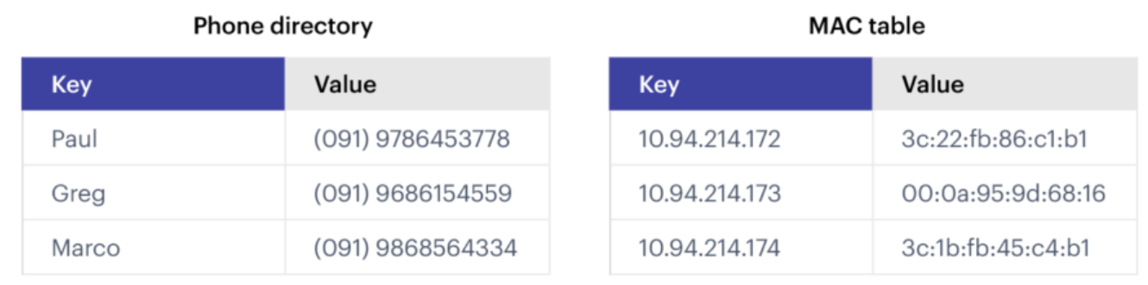
An example of Key-Value database
Use Cases:
- Ideal for scenarios requiring fast reads and writes, such as session stores, caching, and real-time recommendation engines.
- Suitable for applications needing scalable, high-speed retrieval of data by a known key.
Examples & Code Snippet:
Popular key-value stores include Redis and Amazon DynamoDB.
Example using Redis in Python:
import redis
r = redis.Redis(host='localhost', port=6379, db=0)
r.set('foo', 'bar')
print(r.get('foo')) # Output: 'bar'
Comparison with SQL Database
Performance: Key-value stores generally offer faster data access for simple queries due to their straightforward structure, while SQL databases excel in handling complex queries across related data.
Flexibility: Key-value stores provide more flexibility in terms of data modeling since they do not require a predefined schema. In contrast, SQL databases require the definition of tables and relations upfront.
Scalability: Key-value databases are often easier to scale horizontally, making them a good fit for distributed systems. SQL databases can also scale but might require more sophisticated strategies like sharding.
Complexity and Transactions: SQL databases support complex transactions and join operations, which are crucial for many business applications. Key-value stores have limited support for transactions, focusing on speed and simplicity.
Characteristics of Document DB(Ex: MongoDB)
What is MongoDB | MongoDB is a document-oriented NoSQL database that stores data in flexible, JSON-like documents.
DataTypes in MongoDB | MongoDB supports various data types including string, integer, double, boolean, arrays, objects, dates, and null.
What is ObjectId in MongoDB | ObjectId is a 12-byte hexadecimal number that uniquely identifies documents in a collection.
MongoDB Atlas | MongoDB Atlas is a fully managed cloud database service. It provides automated backups, monitoring, and security features.
MongoDB Compass | MongoDB Compass is a graphical user interface for MongoDB. It allows users to visualize data, run queries, and analyze performance.
What is MongoDB Shell | MongoDB Shell is a command-line interface for interacting with MongoDB instances. It allows users to execute queries, perform administrative tasks, and manage databases.
MongoDB is a document-oriented NoSQL database that revolutionizes data storage with its flexibility and scalability. By storing data in JSON-like documents, MongoDB offers developers a powerful and intuitive way to handle complex data structures. From basic CRUD operations to advanced aggregation techniques, MongoDB empowers users to build robust and dynamic applications with ease. CRUD Operations in MongoDB-Create, Read, Update, and Delete documents,

Create and Use a Database
use blog
Create (if not exists) and use the ‘blog’ database

Create Collections
// Create a 'posts' collection
db.createCollection("posts")
// Create a 'users' collection
db.createCollection("users")
Create two collections: posts for storing blog posts and users for storing user information.

Insert Operations
Insert a single document into ‘posts’ collection
db.posts.insertOne({
title: "Introduction to MongoDB",
content: "MongoDB is a NoSQL database.",
author: "John Doe",
tags: ["mongodb", "nosql", "database"]
})

Delete Operations
Delete a document from ‘users’ collection
db.users.deleteOne({ username: "janedoe" })
Characteristics of Column-Family DB(Ex: Cassandra)
Apache Cassandra is an open source, user-available, distributed, NoSQL DBMS which is designed to handle large amounts of data across many servers. It provides zero point of failure. Cassandra offers massive support for clusters spanning multiple datacentres.
There are some massive features of Cassandra. Here are some of the features described below:
- Distributed:
Each node in the cluster has same role. There’s no question of failure & the data set is distributed across the cluster but one issue is there that is the master isn’t present in each node to support request for service.
- Supports replication & Multi data center replication:
Replication factor comes with best configurations in cassandra. Cassandra is designed to have a distributed system, for the deployment of large number of nodes for across multiple data centers and other key features too.
- Scalability:
It is designed to r/w throughput, Increase gradually as new machines are added without interrupting other applications.
- Fault-tolerance:
Data is automatically stored & replicated for fault-tolerance. If a node Fails, then it is replaced within no time.
- MapReduce Support:
It supports Hadoop integration with MapReduce support.Apache Hive & Apache Pig is also supported.
- Query Language:
Cassandra has introduced the CQL (Cassandra Query Language). Its a simple interface for accessing the Cassandra.
Cassandra uses a partitioned row store, which means rows contain columns. A column-family database stores data with keys mapped to values and the values grouped into multiple column families.
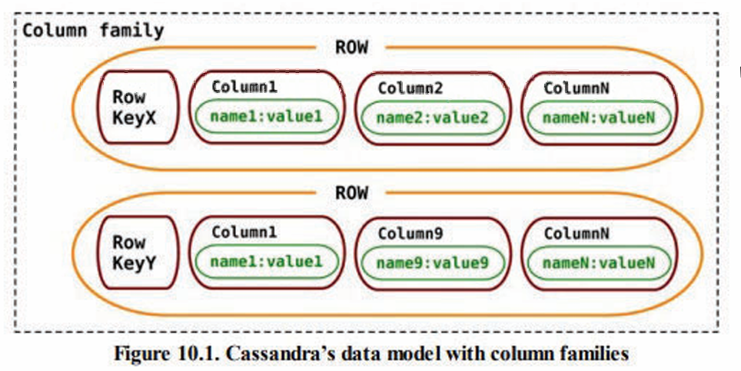

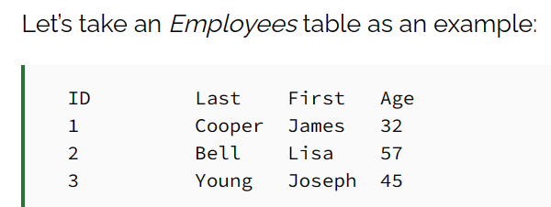
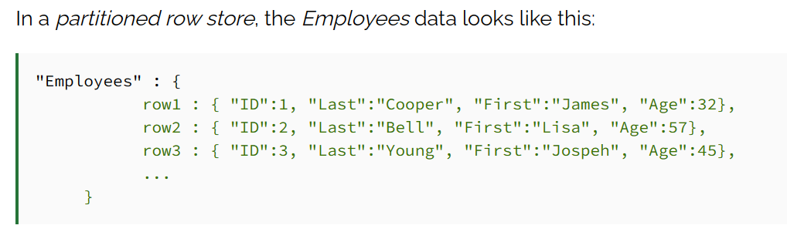
A partitioned row store has rows that contain columns, yet the number of columns in each row does not have to be the same (like big-table). Some rows may have thousands of columns, while some rows could be limited to just one.
We can think of a partitioned row store as a two-dimensional key-value store, where a row key and a column key are used to access data. To access the smallest unit of data (a column), we must first specify the row name (key) and then the column name.
Example:
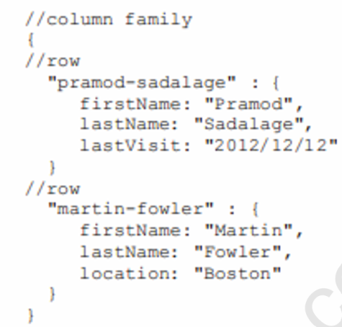

Basic Terminology:
1. Node:
Node is the basic component in Apache Cassandra. It is the place where actually data is stored. For Example:As shown in diagram node which has IP address 10.0.0.7 contain data (keyspace which contain one or more tables).
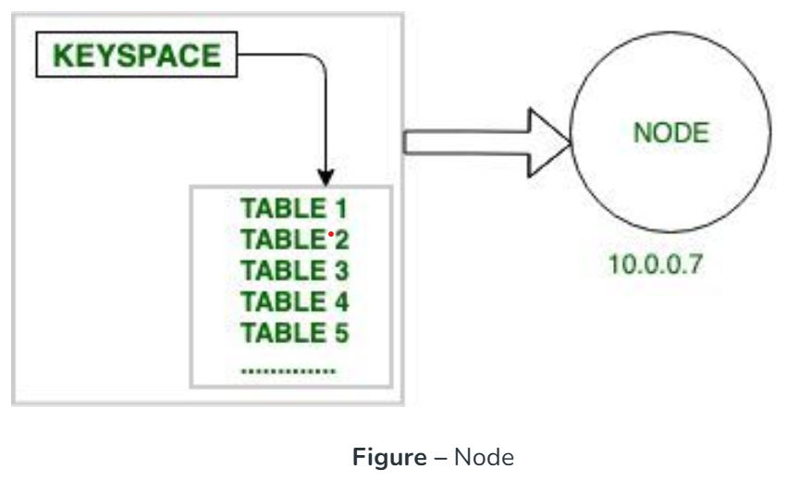
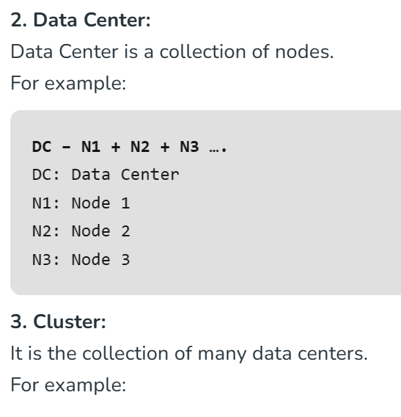
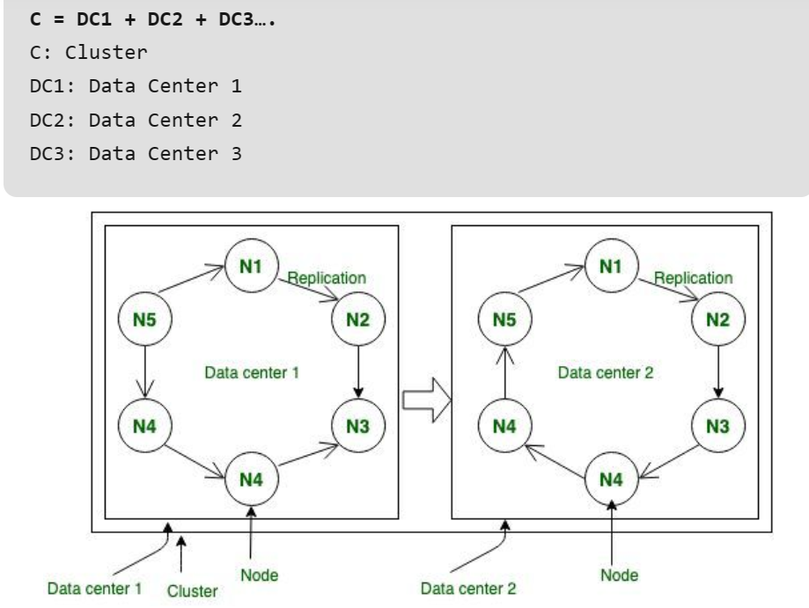
Figure – Node, Data center, Cluster
Characteristics of Graph DB(Ex: ArangoDB)
Graph database systems like ArangoDB can store graphs and provide means to query the connected data.
ArangoDB’s graph model is that of a property graph. Every record, whether vertex or edge, can have an arbitrary number of properties. Each document is a fully-fledged JSON object and has a unique identifier.
ArangoDB’s graph model can be classified as a labeled property graph because you can group related edges using edge collections, with the collection name being the label, but you can also use a property to assign one or more types to an edge. You can also organize vertices in different collections based on the types of entities.
Edges can only be stored in edge collections. Vertices are stored in document collections which are also referred to as vertex collections in the context of graphs.
Named graphs are completely managed by ArangoDB, ensuring data consistency
The following types of named graphs exist:
- General Graphs
- SmartGraphs
- EnterpriseGraph
- SatelliteGraphs
The graph capabilities of ArangoDB are similar to a property graph database but add more flexibility in terms of data modeling as vertices and edges are both full JSON documents.
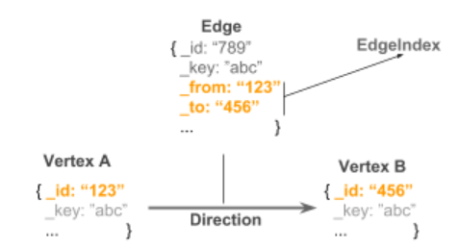
For each document, a unique _id attribute is stored automatically. To build a relation (ie, an edge) between two documents (i.e., vertices), both _id attributes are stored in a special edge document known as _from and _to attributes, forming a directed connection between two arbitrary vertices. Edges are then stored in a special edge collection.
ArangoDB enables efficient and scalable graph query performance by using a special hash index on _from and _to attributes (i.e., an edge index). This allows for constant lookup times. Using an edge index, ArangoDB can process graph queries very efficiently.
Vertices and edges are both full JSON documents and can hold arbitrary data. By this approach combined with the edge index, ArangoDB is one of the few graph databases capable of horizontal scaling. Each edge and vertex can contain complex data in the form of nested properties, and all graph functions are deeply integrated into the ArangoDB Query Language, (AQL).

The ArangoDB Query Language (AQL) lets you store, retrieve, and modify data in various ways in ArangoDB.
AQL is similar to the Structured Query Language (SQL). AQL supports reading and modifying collection data, but it doesn’t support data-definition operations such as creating and dropping databases, collections and indexes. It is a pure data manipulation language (DML), not a data definition language (DDL) or a data control language (DCL).
As your application grows, chances are the size of your graph will grow along with it. In order to make sure graph traversals stay as performant as possible, even when being sharded across multiple servers in a cluster, ArangoDB provides a solution in the form of SmartGraphs.
The primary hit to performance comes from network latency. As shown below, when doing a traversal with data sharded across a cluster, multiple back and forth network hops are usually necessary and this can have a large impact on performance. For larger datasets this is a common situation and SmartGraphs reduces the needed network hops by intelligently sharding data.
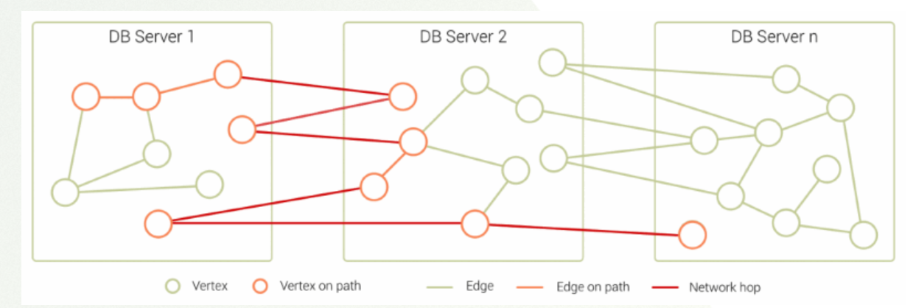

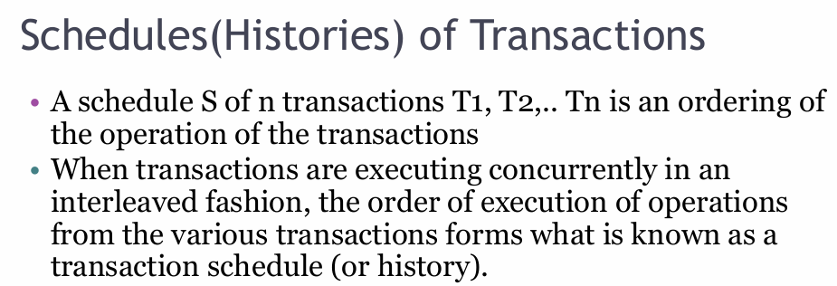
In DBMS, schedules may be classified as-
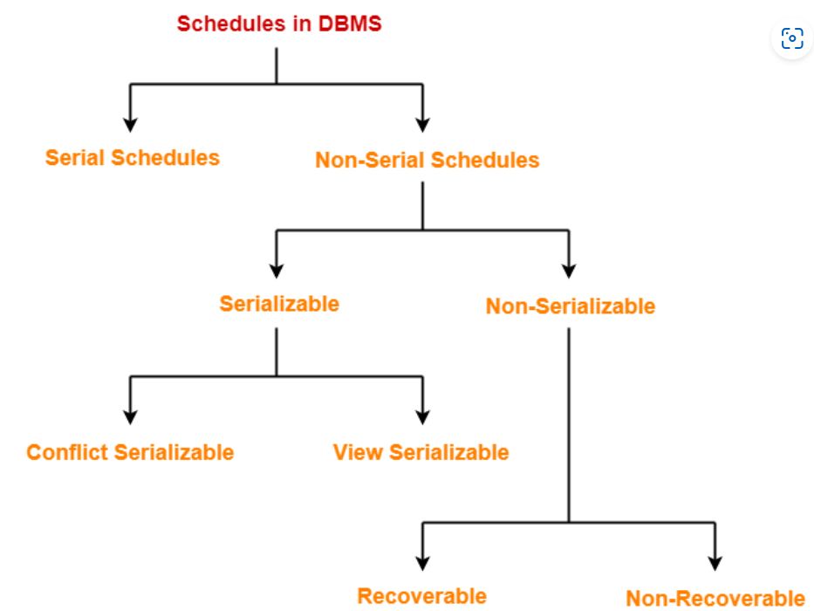
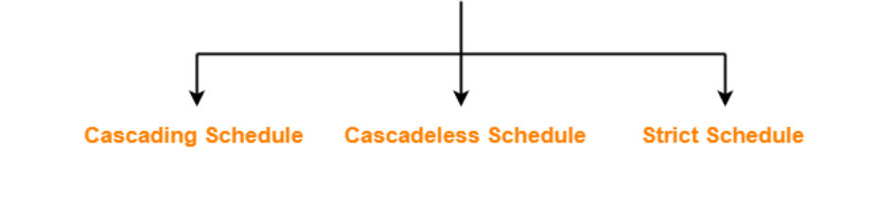

Serial Schedules-
In serial schedules,
- All the transactions execute serially one after the other.
- When one transaction executes, no other transaction is allowed to execute.
Characteristics-
Serial schedules are always-
- Consistent
- Recoverable
- Cascadeless
- Strict
Example 1:
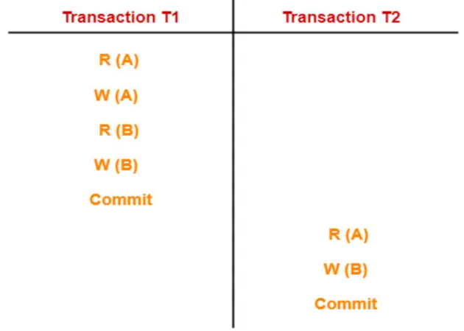
In this Schedule,
- There are two transactions T1 and T2 executing serially one after the other.
- Transaction T1 executes first.
- After T1 completes its execution, transaction T2 executes.
- So, this schedule is an example of a Serial Schedule.
Example 2:
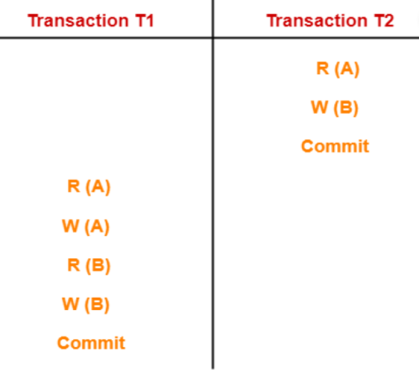
In this schedule,
- There are two transactions T1 and T2 executing serially one after the other.
- Transaction T2 executes first.
- After T2 completes its execution, transaction T1 executes.
- So, this schedule is an example of a Serial Schedule.
Example 3:
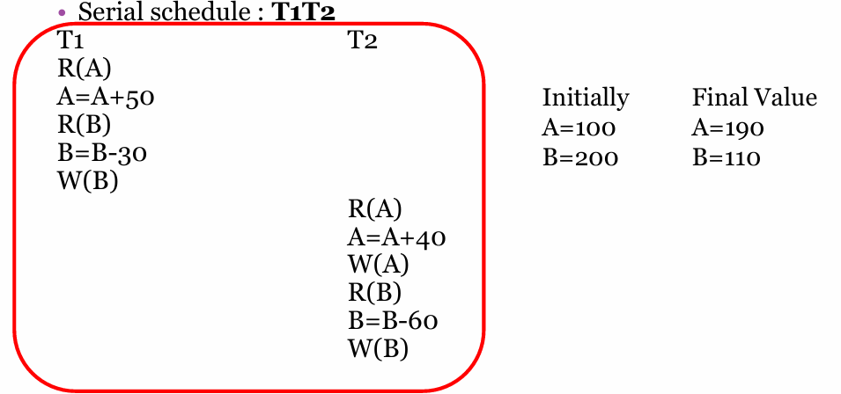

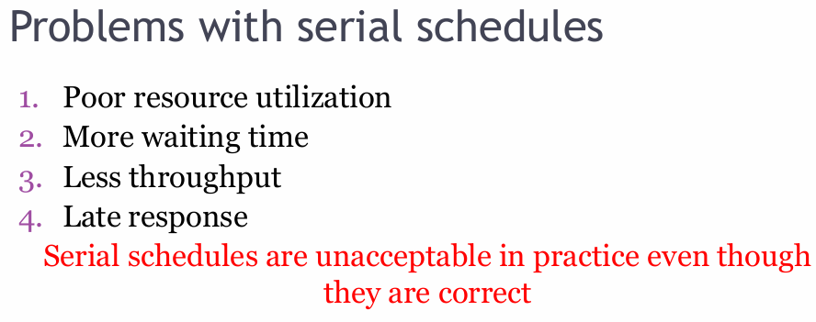
Non-Serial Schedules-
In non-serial schedules,
- Multiple transactions execute concurrently.
- Operations of all the transactions are inter leaved or mixed with each other.
Characteristics-
Non-serial schedules are NOT always-
- Consistent
- Recoverable
- Cascadeless
- Strict
Example 1:
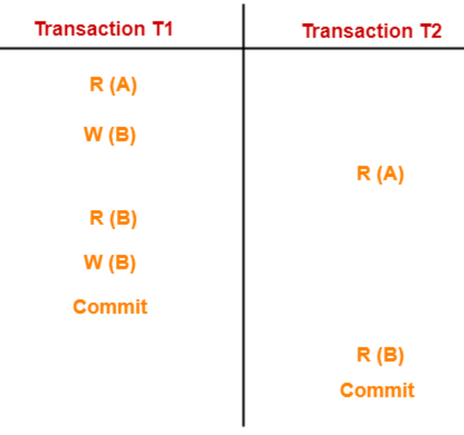
In this schedule,
- There are two transactions T1 and T2 executing concurrently.
- The operations of T1 and T2 are interleaved.
- So, this schedule is an example of a Non-Serial Schedule.
Example 2:
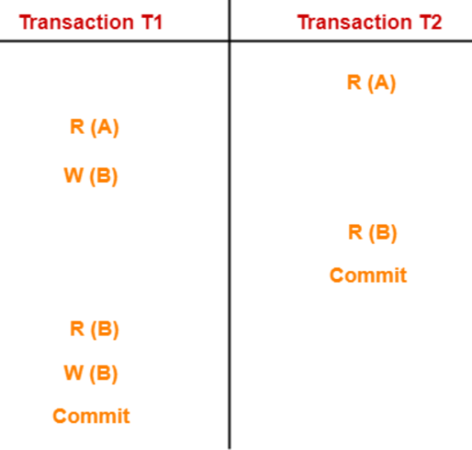
In this schedule,
- There are two transactions T1 and T2 executing concurrently.
- The operations of T1 and T2 are interleaved.
- So, this schedule is an example of a Non-Serial Schedule
Example 3:
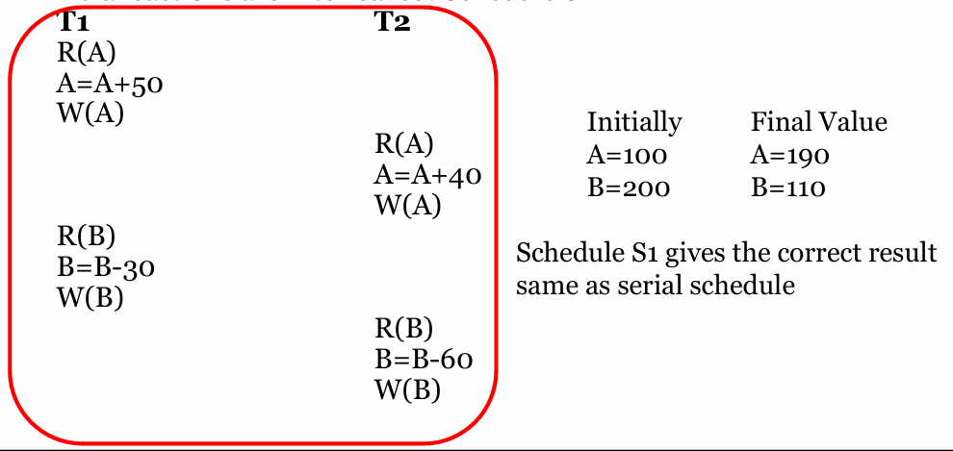
Example 4:
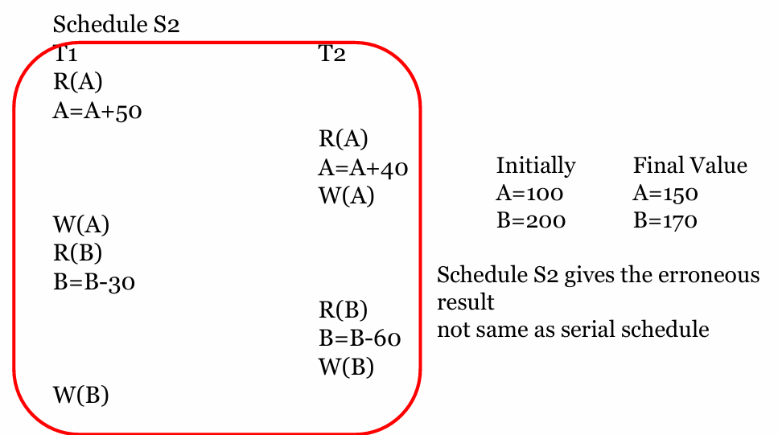
Summary:
- Serial schedules always give correct result.
- But there are some drawbacks.
- In order to avoid that we introduced non serial schedules.
- But not all non serial schedules are correct.
- So we need a non serial schedule which always give a correct result.
- or Equivalent to a Serial schedule = Serializable schedule.
Serializability in DBMS-
Some non-serial schedules may lead to inconsistency of the database.
Serializability is a concept that helps to identify which non-serial schedules are correct and will maintain the consistency of the database.
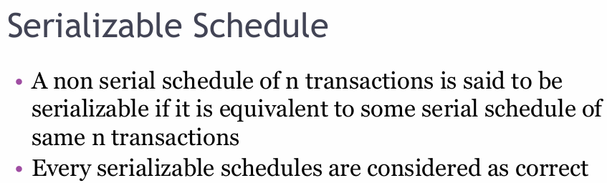
Characteristics
Serializable schedules behave exactly same as serial schedules.
Thus Serializale schedules are always-
- Consistent
- Recoverable
- Casacadeless
- Strict
Serializability is mainly of two types-
1) Conflict Serializability
2) View Serializability
Conflict Serializability-
If a given non-serial schedule can be converted into a serial schedule by swapping its non-conflicting operations, then it is called as a conflict serializable schedule.
Conflicting Operations-
Two operations are called as conflicting operations if all the following conditions hold true for them-
- Both the operations belong to different transactions
- Both the operations are on the same data item
- At least one of the two operations is a write operation
Example:
R(A) R(A) - Non conflict pair
R(A) W(A)- Conflict pair
W(A) R(A) - Conflict pair
W(A) W(A) - Conflict pair
R(B) R(A) - Non conflict pair
W(B) R(A) - Non conflict pair
R(B) W(A) -Non conflict pair
W(A) W(B) -Non conflict pair
Checking Whether a Schedule is Conflict Serializable Or Not-
Follow the following steps to check whether a given non-serial schedule is conflict serializable or not-
Step-01:
Find all the conflicting operations.
Step-02:
Start creating a precedence graph by drawing one node for each transaction.
Step-03:
Draw an edge for each conflict pair such that if Xi (V) and Yj (V) forms a conflict pair then draw an edge from Ti to Tj.
This ensures that Ti gets executed before Tj.
Step-04:
Check if there is any cycle formed in the graph.
If there is no cycle found, then the schedule is conflict serializable otherwise not.
Example 1:
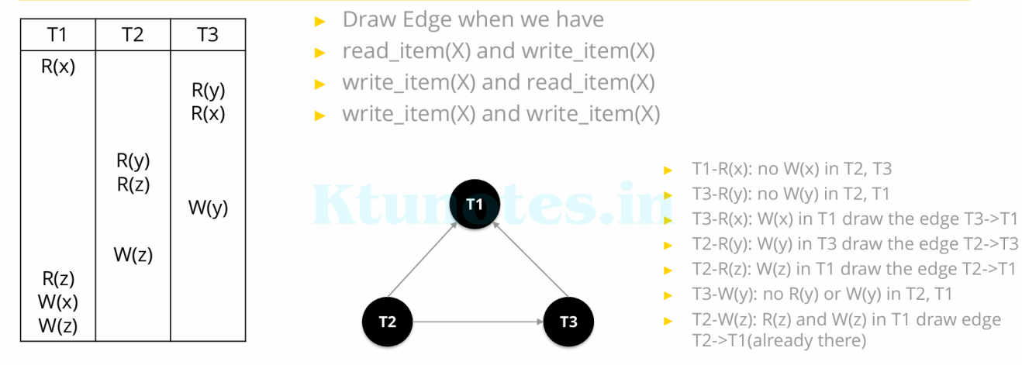
As we have no cycle/loop in the precedence graph, these schedule is conflict serializable.
Example 2:
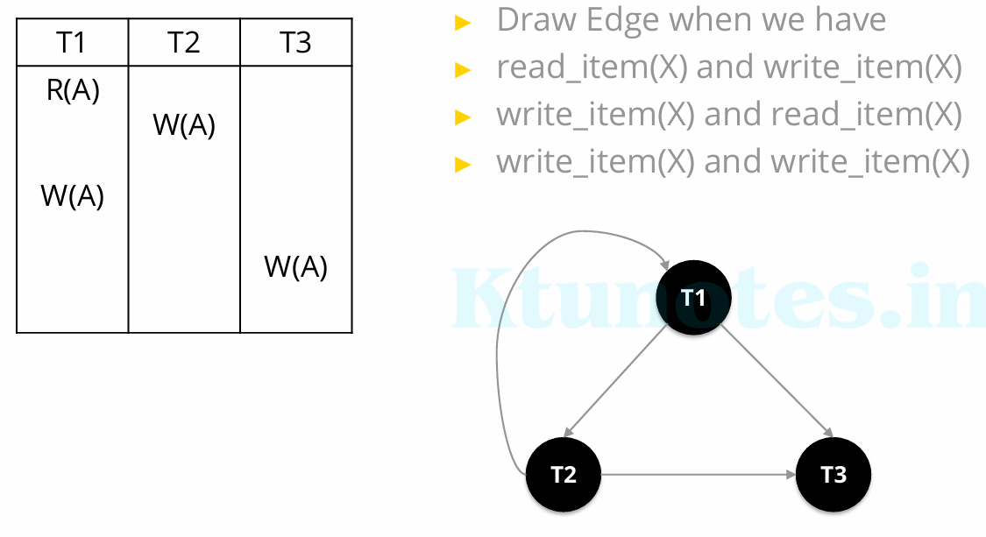
As we have cycle/loop in the precedence graph, these schedule is not conflict serializable.
Example 3: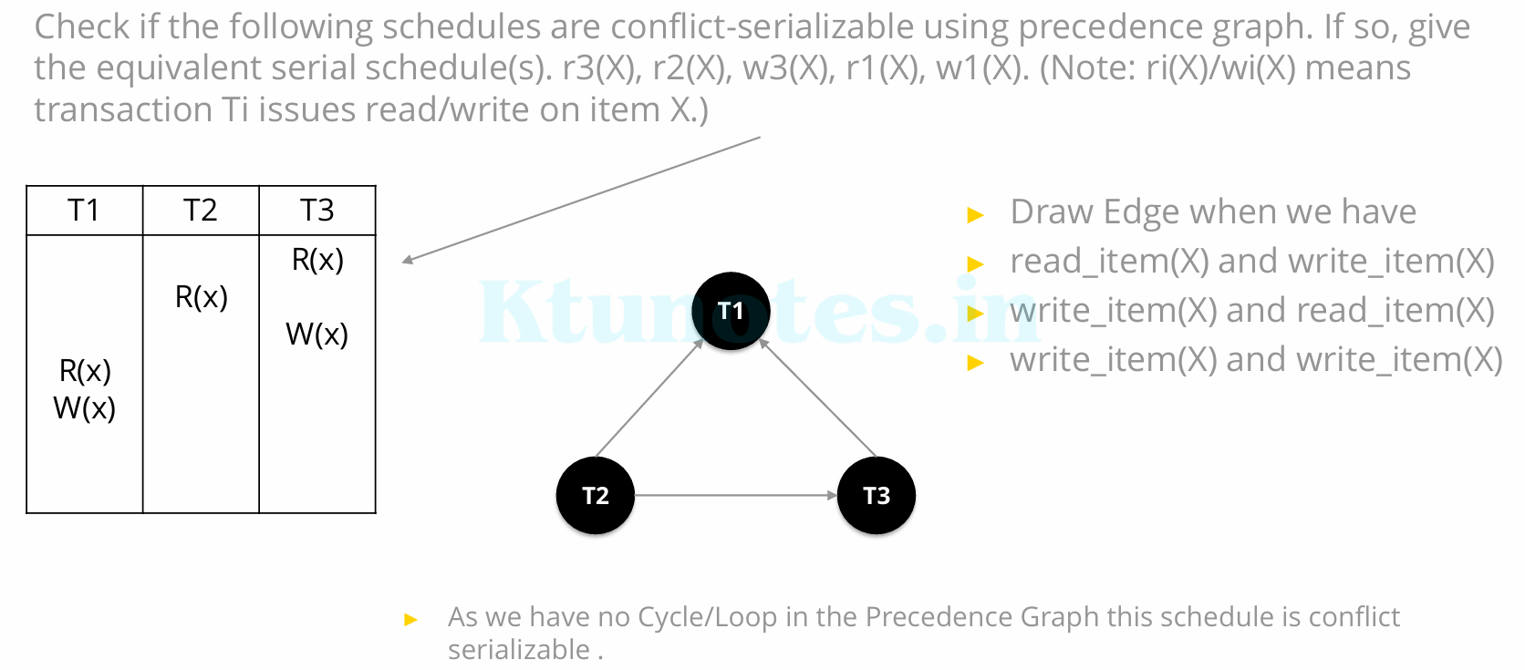
Refer Questions in note
Conflict Equivalence
Two schedules are said to be Conflict Equivalent if the relative order of any two conflicting operations is the same in both schedules.
- In the conflict equivalent, one can be transformed to another by swapping non-conflicting operations.
- Two schedules are said to be conflict equivalent if and only if:
► They contain the same set of the transaction.
► If each pair of conflict operations are ordered in the same way
Example 1:
Check whether the following two schedules are conflict equivalent or not?
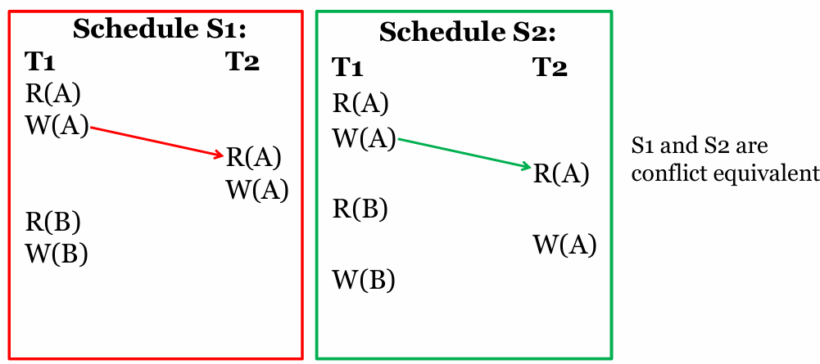
Example 2:
Check whether the following two schedules are conflict equivalent or not?
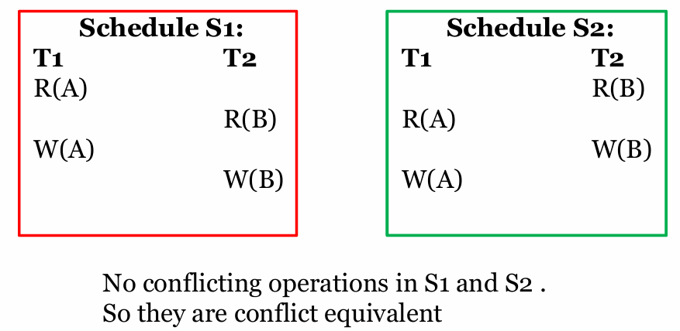
Example 3:
Check whether the following two schedules are conflict equivalent or not?
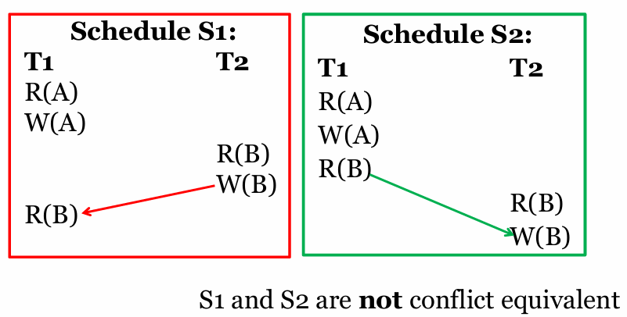
View Serializable
- View Serializability is a process to find out that a given schedule is view serializable or not.
- To check whether a given schedule is view serializable, we need to check whether the given schedule is View Equivalent to its serial schedule.
- Lets take an example to understand what I mean by that.
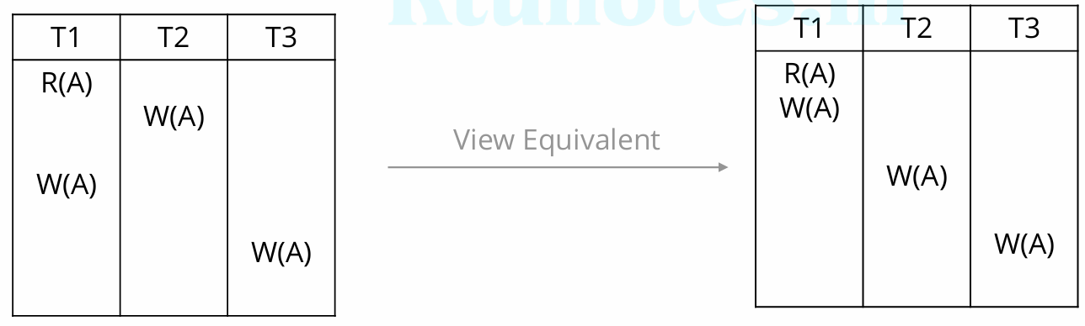
Two schedules S1 and S2 are said to be view equivalent if they satisfy the
following conditions:
1) Initial Read
► An initial read of both schedules must be the same.
► Suppose two schedule S1 and S2. In schedule S1, if a transaction T1 is
reading the data item A, then in S2, transaction T1 should also read A.
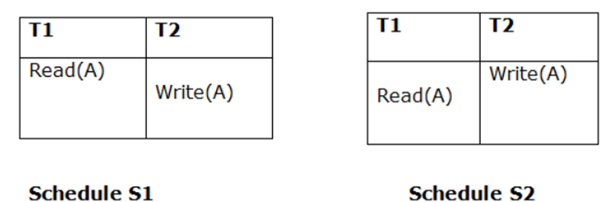
These schedules are view equivalent because Initial read operation in S1 is
done by T1 and in S2 it is also done by T1.
2) Updated Read
► In schedule S1, if Ti is reading A which is updated by Tj then in S2 also, Ti should read A which is updated by Tj.
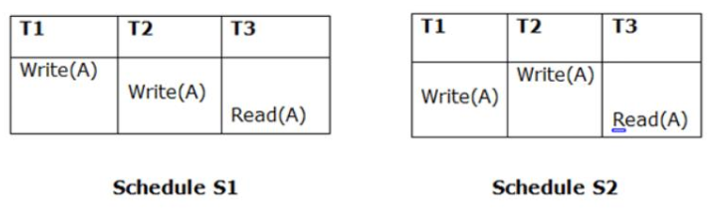
These two schedules are not view equal because, in S1, T3 is reading A updated by T2 and in S2, T3 is reading A updated by T1.
3) Final Write
► A final write must be the same between both the schedules. In schedule S1, if a transaction T1 updates A at last then in S2, final writes operations should also be done by T1.
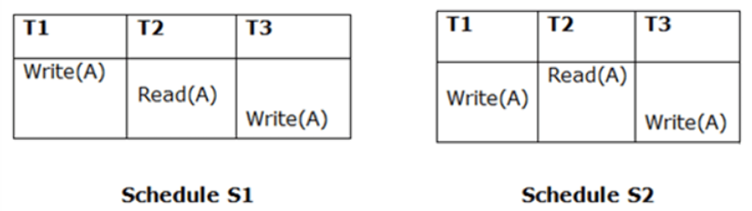
These two schedules is view equal because Final write operation in S1 is done by T3 and in S2, the final write operation is also done by T3.
Example 1:
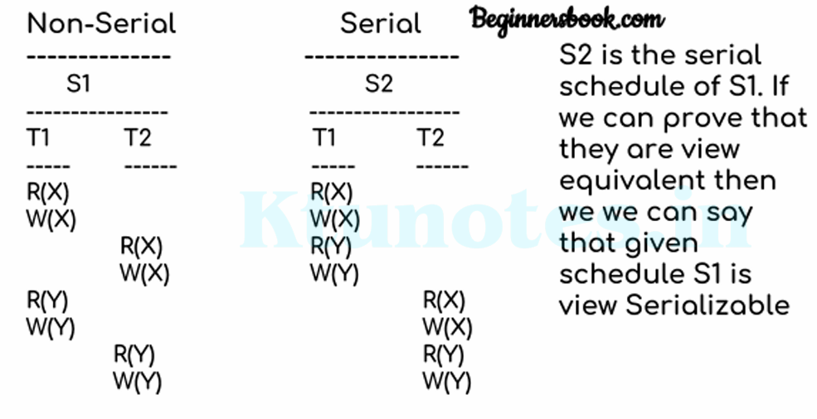
Lets check the three conditions of view serializability:
1) Initial Read
- In schedule S1, transaction T1 first reads the data item X.
- In S2 also transaction T1 first reads the data item X.
- Lets check for Y. In schedule S1, transaction T1 first reads the data item Y. In S2 also the first read operation on Y is performed by T1.
- We checked for both data items X & Y and the initial read condition is satisfied in S1 & S2
2) Update Read
- In S1, transaction T2 reads the value of X, written by T1. In S2, the same transaction T2 reads the X after it is written by T1.
- In S1, transaction T2 reads the value of Y, written by T1. In S2, the same transaction T2 reads the value of Y after it is updated by T1.
- The update read condition is also satisfied for both the schedules
3) Final Write
- In schedule S1, the final write operation on X is done by transaction T2. In S2 also transaction T2 performs the final write on X.
- Lets check for Y. In schedule S1, the final write operation on Y is done by transaction T2. In schedule S2, final write on Y is done by T2.
- We checked for both data items X & Y and the final write condition is satisfied in S1 & S2
Result: Since all the three conditions that checks whether the two schedules are view equivalent are satisfied in this example, which means S1 and S2 are view equivalent.
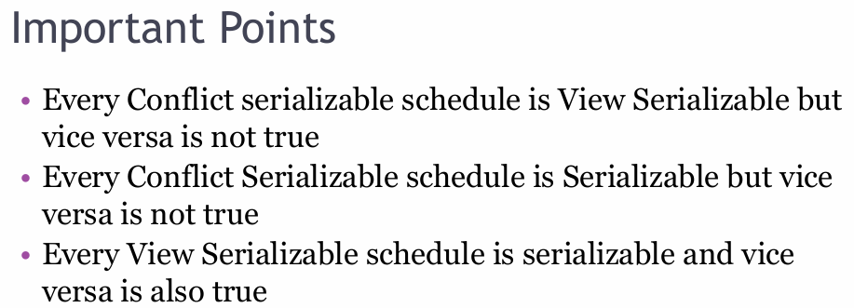
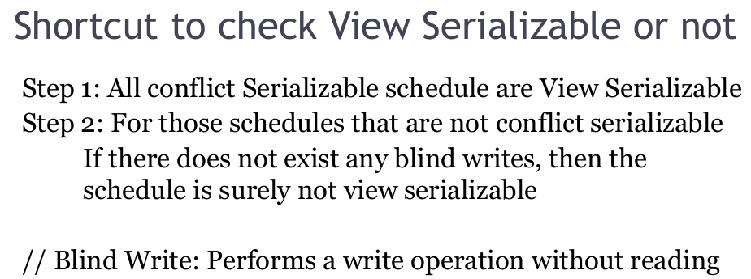
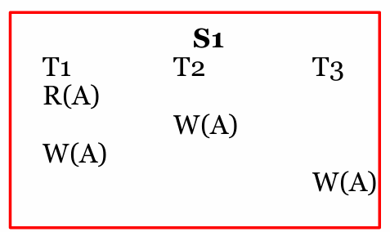
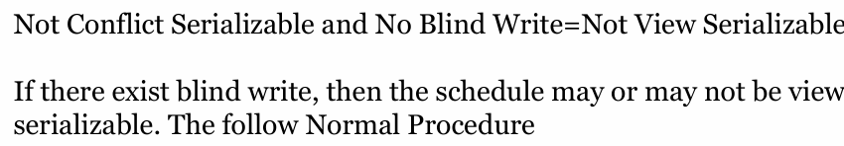
Non-Serializable Schedules-
- A non-serial schedule which is not serializable is called as a non-serializable schedule.
- A non-serializable schedule is not guaranteed to produce the the same effect as produced by some serial schedule on any consistent database.
Characteristics-
Non-serializable schedules-
- may or may not be consistent
- may or may not be recoverable
Irrecoverable Schedules-
If in a schedule,
- A transaction performs a dirty read operation from an uncommitted transaction and commits before the transaction from which it has read the value then such a schedule is known as an Irrecoverable Schedule.
Example,
Consider the following schedule-
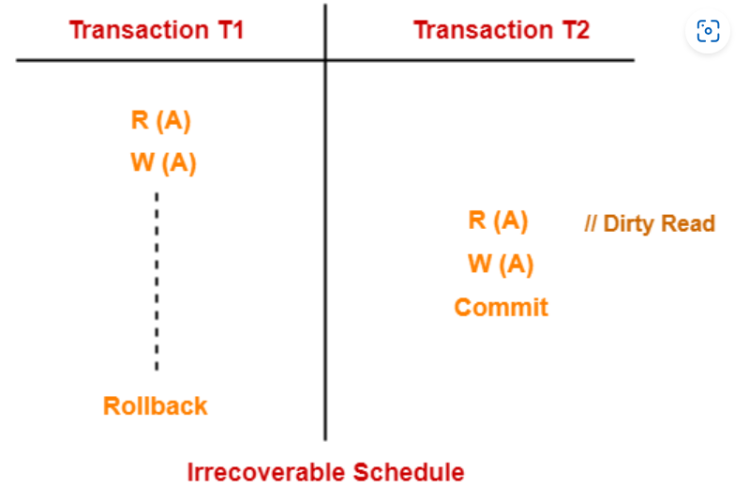
Here,
- T2 performs a dirty read operation.
- T2 commits before T1.
- T1 fails later and roll backs.
- The value that T2 read now stands to be incorrect.
- T2 can not recover since it has already committed.
Recoverable Schedules-
If in a schedule,
A transaction performs a dirty read operation from an uncommitted transaction and its commit operation is delayed till the uncommitted transaction either commits or roll backs then such a schedule is known as a Recoverable Schedule.
Here,
- The commit operation of the transaction that performs the dirty read is delayed.
- This ensures that it still has a chance to recover if the uncommitted transaction fails later.
Example,
Consider the following schedule-
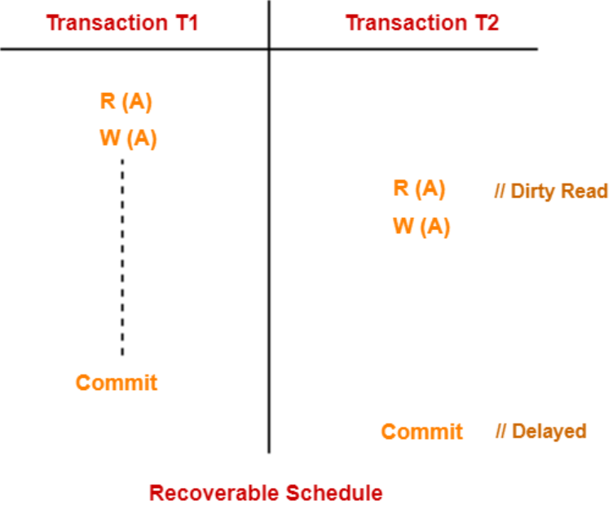
Here,
- T2 performs a dirty read operation.
- The commit operation of T2 is delayed till T1 commits or roll backs.
- T1 commits later.
- T2 is now allowed to commit.
- In case, T1 would have failed, T2 has a chance to recover by rolling back.
Checking Whether a Schedule is Recoverable or Irrecoverable-
Method-01:
Check whether the given schedule is conflict serializable or not.
- If the given schedule is conflict serializable, then it is surely recoverable. Stop and report your answer.
- If the given schedule is not conflict serializable, then it may or may not be recoverable. Go and check using other methods.
Method-02:
Check if there exists any dirty read operation.(Reading from an uncommitted transaction is called as a dirty read)
- If there does not exist any dirty read operation, then the schedule is surely recoverable. Stop and report your answer.
- If there exists any dirty read operation, then the schedule may or may not be recoverable.
If there exists a dirty read operation, then follow the following cases-
Case-01:
If the commit operation of the transaction performing the dirty read occurs before the commit or abort operation of the transaction which updated the value, then the schedule is irrecoverable.
Case-02:
If the commit operation of the transaction performing the dirty read is delayed till the commit or abort operation of the transaction which updated the value, then the schedule is recoverable.
NOTE:
- All conflict serializable schedules are recoverable.
- All recoverable schedules may or may not be conflict serializable.
Example 1:
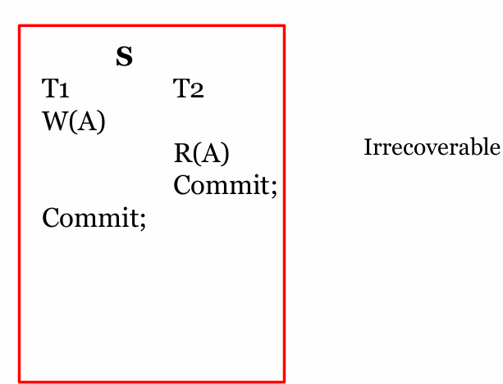
Example 2:
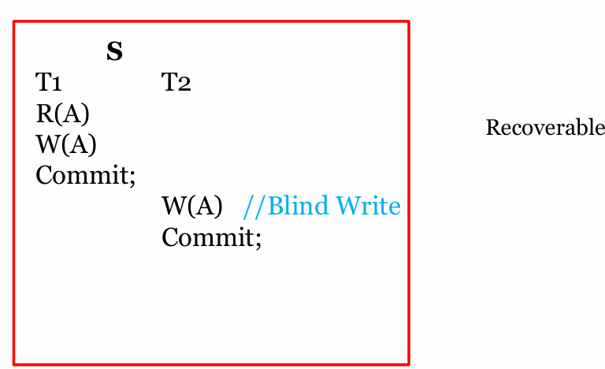
Example 3:
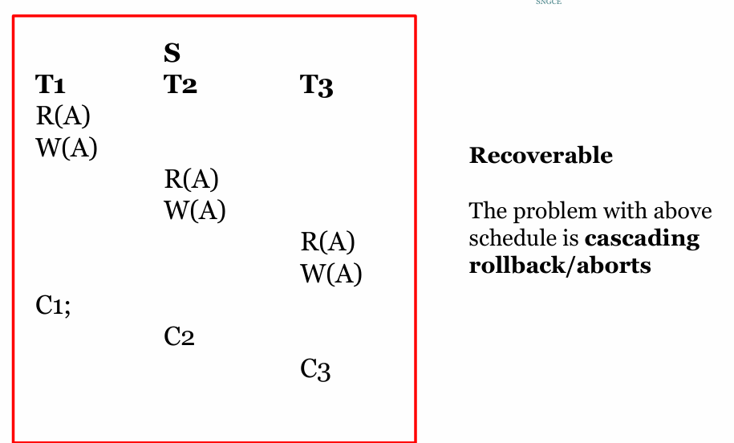
A recoverable schedule may be any one of these kinds-
1)Cascading Schedule
2)Cascadeless Schedule
3)Strict Schedule
Cascading Schedule-
If in a schedule, failure of one transaction causes several other dependent transactions to rollback or abort, then such a schedule is called as a Cascading Schedule or Cascading Rollback or Cascading Abort.
It simply leads to the wastage of CPU time.
Example-
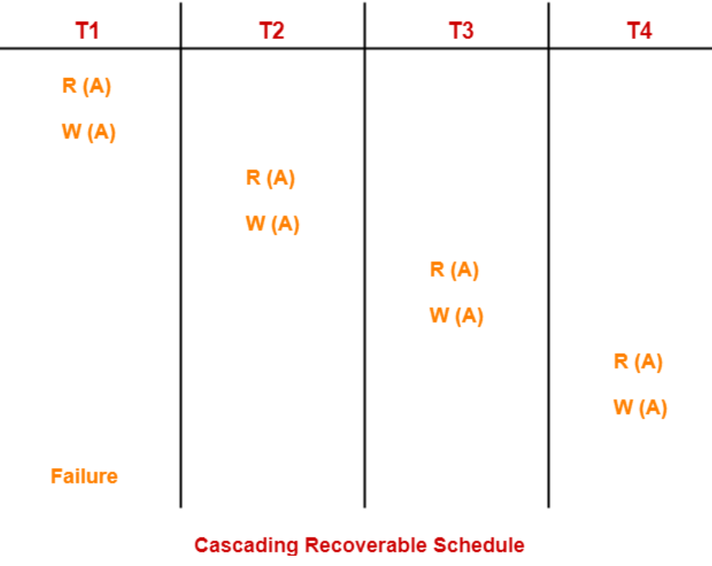
Here,
- Transaction T2 depends on transaction T1.
- Transaction T3 depends on transaction T2.
- Transaction T4 depends on transaction T3.
In this schedule,
- The failure of transaction T1 causes the transaction T2 to rollback.
- The rollback of transaction T2 causes the transaction T3 to rollback.
- The rollback of transaction T3 causes the transaction T4 to rollback.
Such a rollback is called as a Cascading Rollback.
NOTE-
If the transactions T2, T3 and T4 would have committed before the failure of transaction T1, then the schedule would have been irrecoverable.
Cascadeless Schedule-
If in a schedule, a transaction is not allowed to read a data item until the last transaction that has written it is committed or aborted, then such a schedule is called as a Cascadeless Schedule.
In other words,
- Cascadeless schedule allows only committed read operations.
- Therefore, it avoids cascading roll back and thus saves CPU time.
Example-
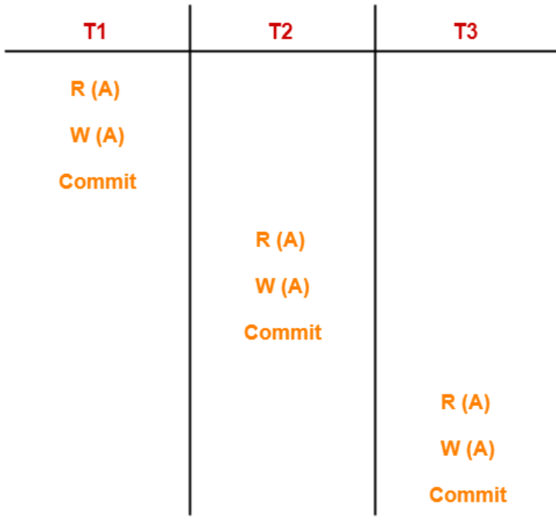
NOTE-
- Cascadeless schedule allows only committed read operations.
- However, it allows uncommitted write operations.
Example-
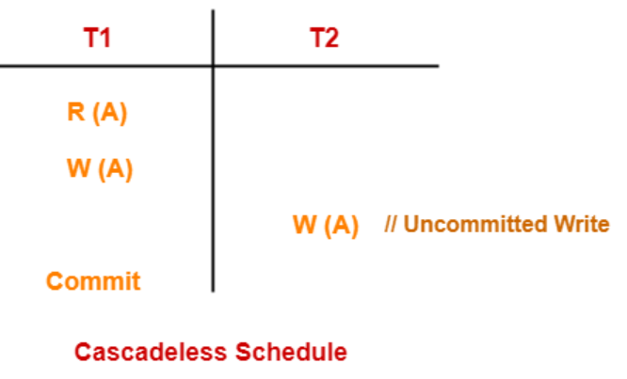
Example:
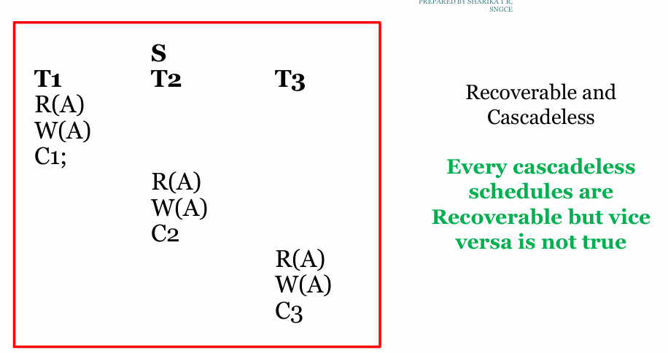
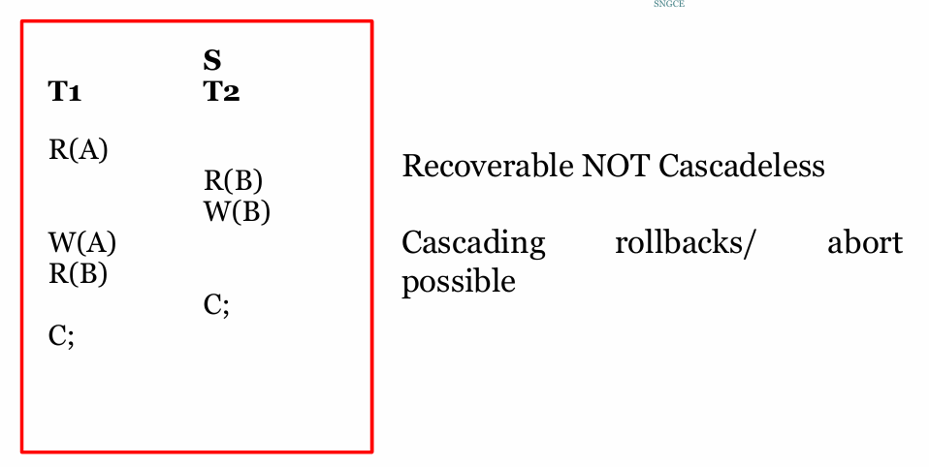
Strict Schedule-
If in a schedule, a transaction is neither allowed to read nor write a data item until the last transaction that has written it is committed or aborted, then such a schedule is called as a Strict Schedule.
In other words,
- Strict schedule allows only committed read and write operations.
- Clearly, strict schedule implements more restrictions than cascadeless schedule.
Example-
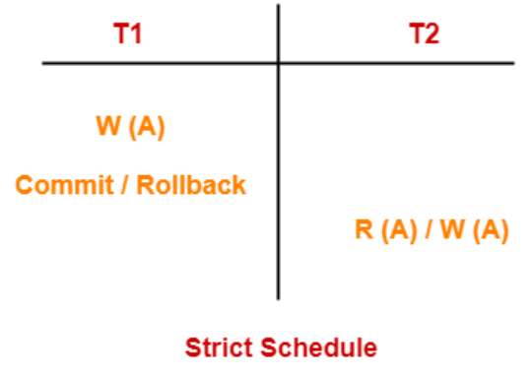
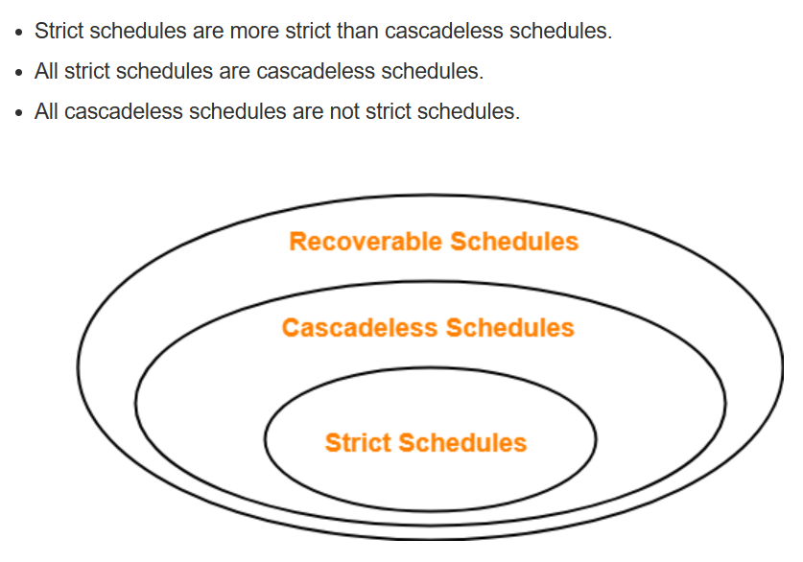
Example:
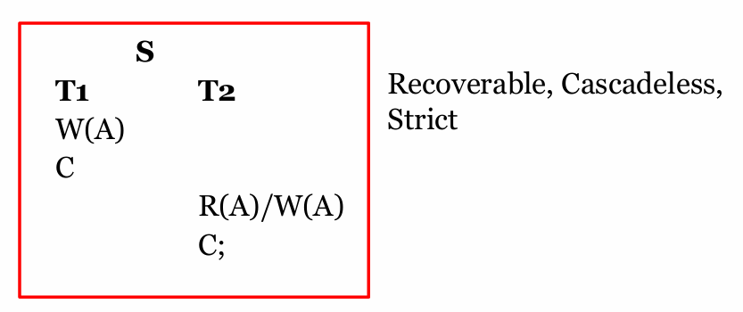

Concurrency Control Protocols
Concurrency control protocols are the set of rules which are maintained in order to solve the concurrency control problems in the database. It ensures that the concurrent transactions can execute properly while maintaining the database consistency. The concurrent execution of a transaction is provided with atomicity, consistency, isolation, durability, and serializability via the concurrency control protocols.

If every individual transaction follows concurrency control protocol then all schedules in which those transaction participate become serializable.
Three type of Concurrency Control Protocols
1. Lock based Protocols
2. Time stamp based Protocol
3. Graph based protocols
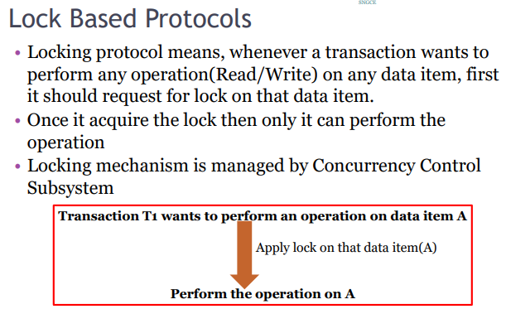
In locked based protocol, each transaction needs to acquire locks before they start accessing or modifying the data items. There are two types of locks used in databases.
1. Shared Lock(S(A))
2. Exclusive Lock(X(A))
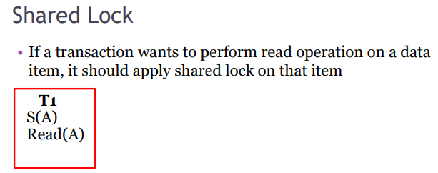
Shared lock is also known as read lock which allows multiple transactions to read the data simultaneously. The transaction which is holding a shared lock can only read the data item but it can not modify the data item.
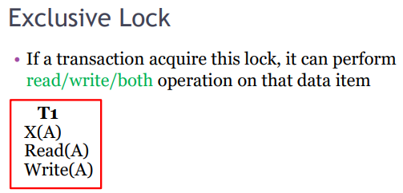
Exclusive lock is also known as the write lock. Exclusive lock allows a transaction to update a data item. Only one transaction can hold the exclusive lock on a data item at a time. While a transaction is holding an exclusive lock on a data item, no other transaction is allowed to acquire a shared/exclusive lock on the same data item.
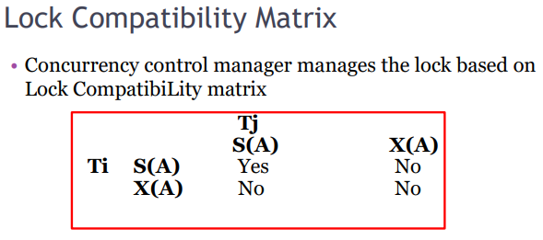
Multiple shared locks on same data item is allowed But all other combinations are not allowed
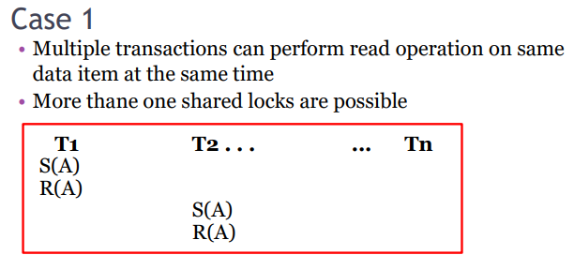
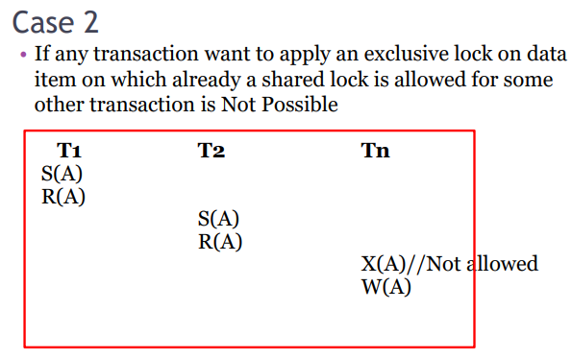
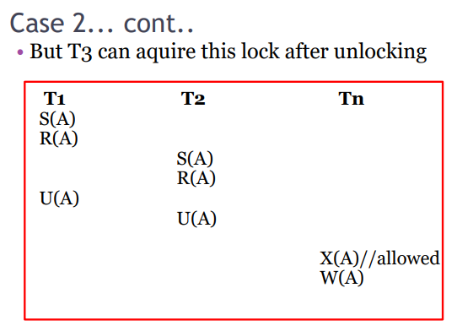
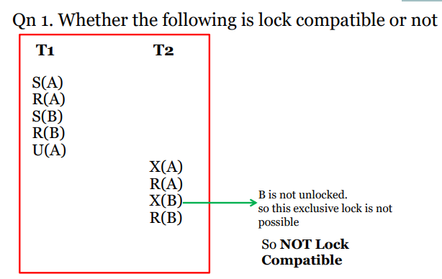
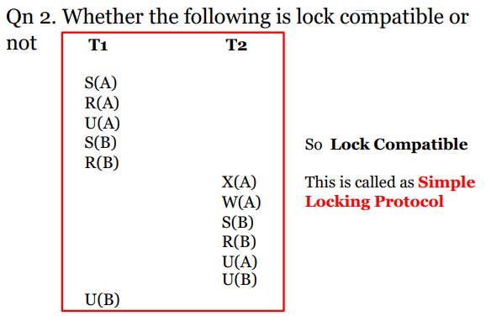
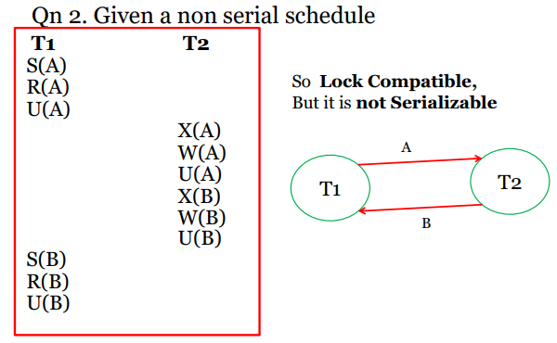
Problems with Simple Locking Protocol
- May not sufficient to produce only serializable schedule.
- May not free from Irrecoverability.
- May not free from deadlock.
- May not free from starvation.
Two phase Locking (2PL)
Two phase locking is a widely used technique which ensures strict ordering of lock acquisition and release. Two phase locking protocol works in two phases.
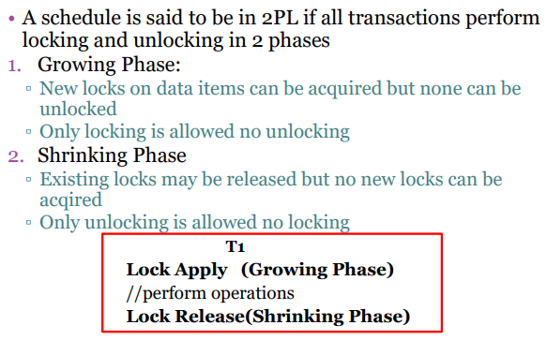
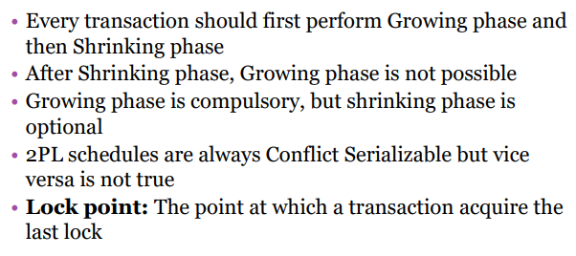
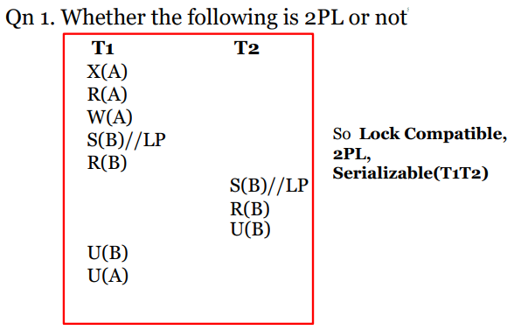
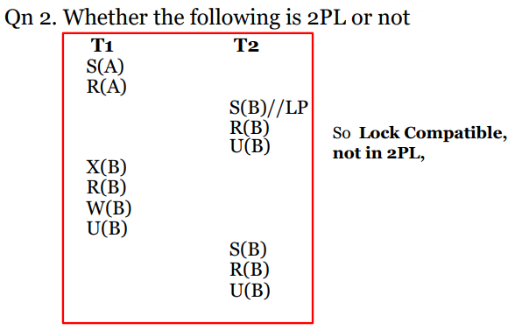
Advantage of 2PL: Always ensures serializability
Problem with Basic 2PL
1. Basic 2PL does not ensure Recoverability
2. Cascading rollbacks are possible
3. Deadlocks are possible.
4. Not free from starvation
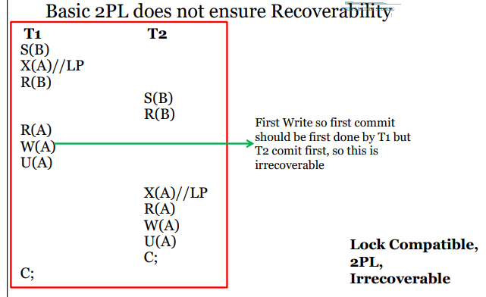
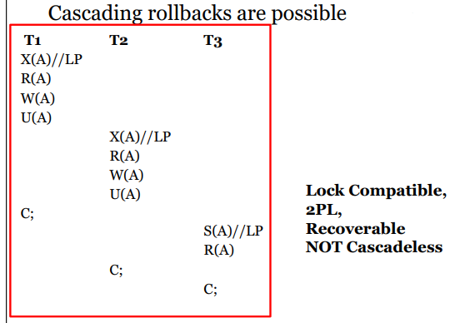
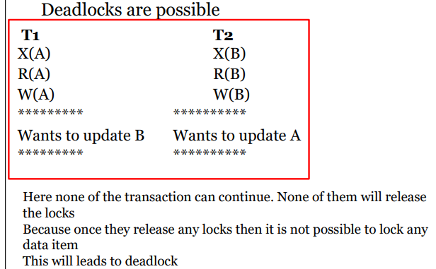
These drawback can be removed by using the following variation of basic 2PL.
Variations of 2PL
1. Strict 2PL
2. Rigorous 2PL
3. Conservative 2PL
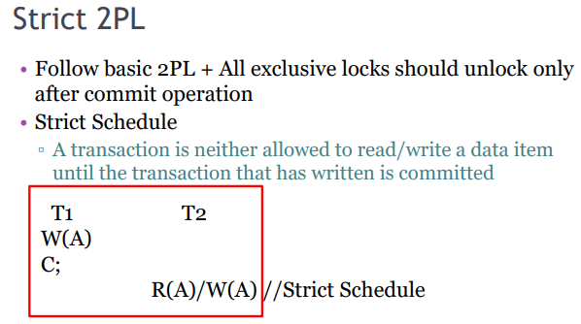
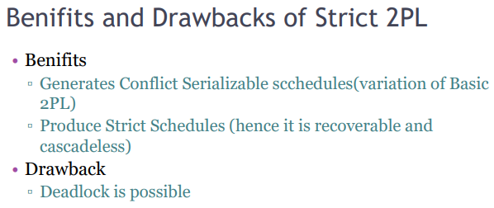
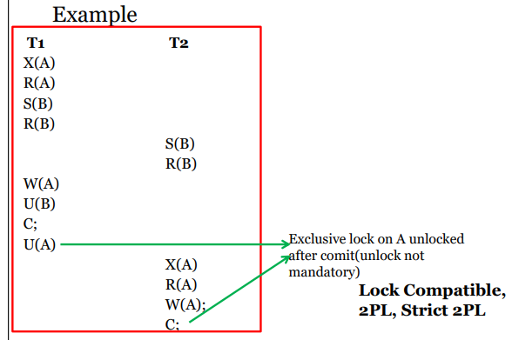
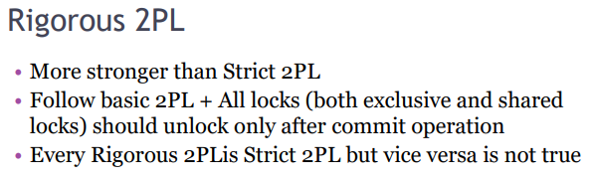
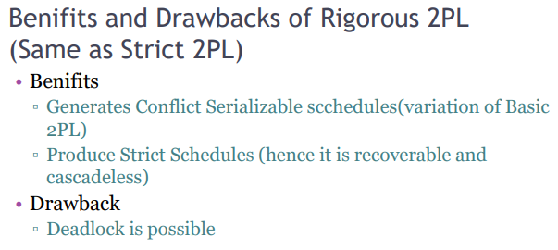
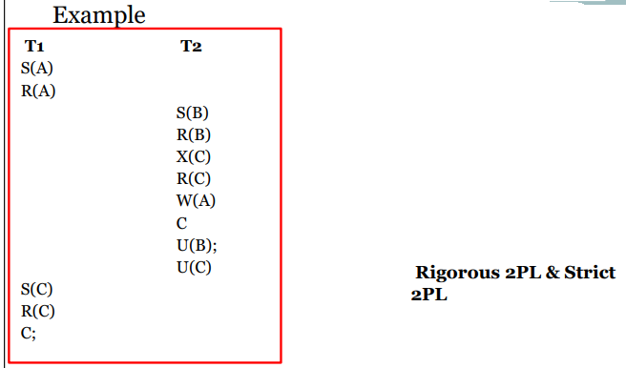
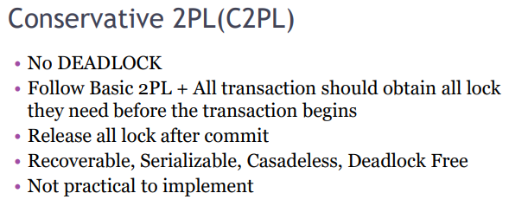
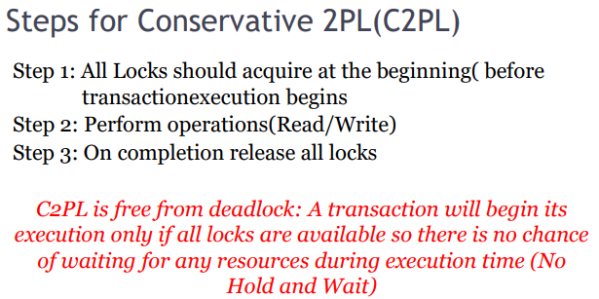
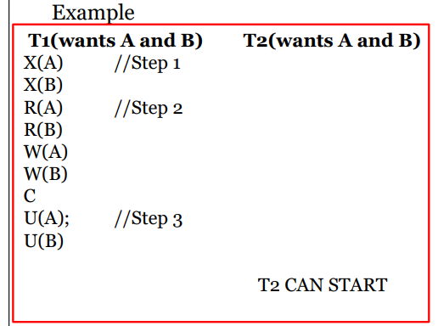
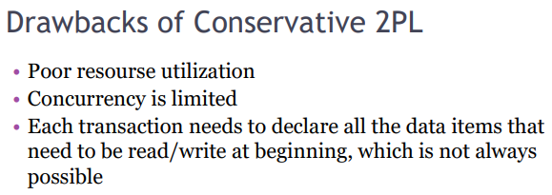
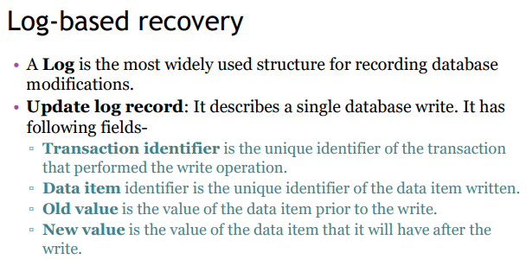
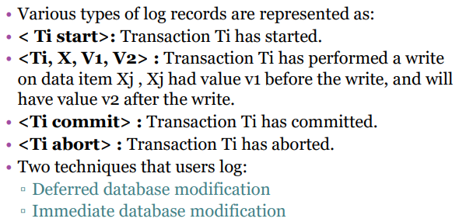
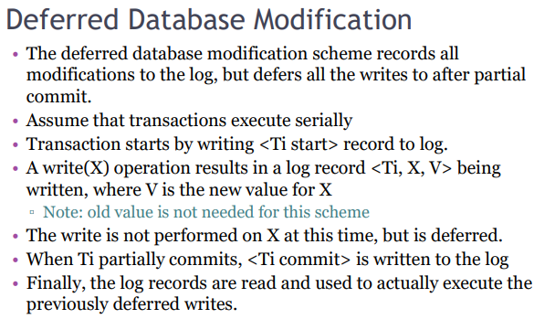
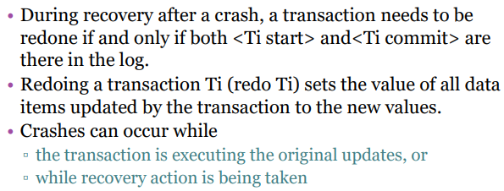
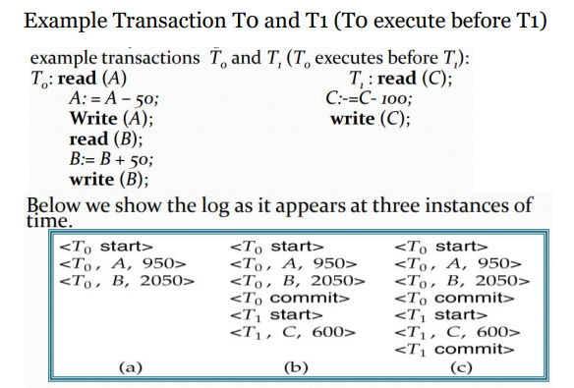
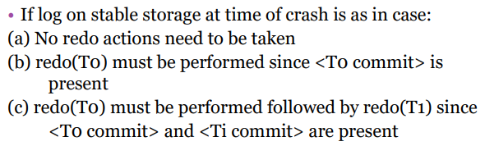
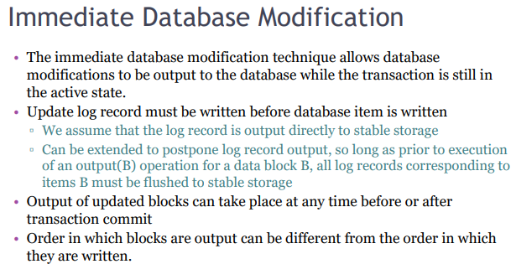
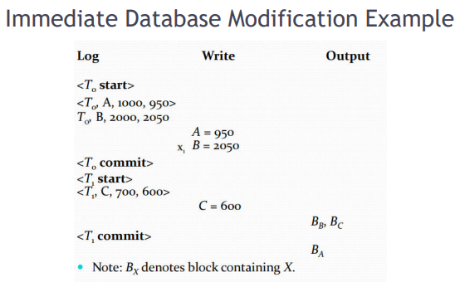
CHECKPOINTING
- The checkpoint is a type of mechanism where all the previous logs are removed from the system and permanently stored in the storage disk.
- The checkpoint is like a bookmark. While the execution of the transaction, such checkpoints are marked, and the transaction is executed then using the steps of the transaction, the log files will be created.
- When it reaches to the checkpoint, then the transaction will be updated into the database, and till that point, the entire log file will be removed from the file. Then the log file is updated with the new step of transaction till next checkpoint and so on.
- The checkpoint is used to declare a point before which the DBMS was in the consistent state, and all transactions were committed.

Recovery using Checkpoint
In the following manner, a recovery system recovers the database from this failure:
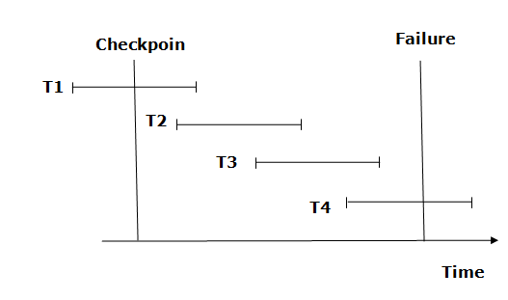
- The recovery system reads log files from the end to start. It reads log files from T4 to T1.
- Recovery system maintains two lists, a redo-list, and an undo-list.
- The transaction is put into redo state if the recovery system sees a log with <Tn, Start> and <Tn, Commit> or just <Tn, Commit>. In the redo-list and their previous list, all the transactions are removed and then redone before saving their logs.
- For example: In the log file, transaction T2 and T3 will have <Tn, Start> and <Tn, Commit>. The T1 transaction will have only <Tn, commit> in the log file. That's why the transaction is committed after the checkpoint is crossed. Hence it puts T1, T2 and T3 transaction into redo list.
- The transaction is put into undo state if the recovery system sees a log with <Tn, Start> but no commit or abort log found. In the undo-list, all the transactions are undone, and their logs are removed.
- For example: Transaction T4 will have <Tn, Start>. So T4 will be put into undo list since this transaction is not yet complete and failed amid.

